Physics 1 Unit 3 – Forces Name: ___________________________

IB 2.2 Forces - Second Law Problems

**Second Law Problems**

1. A lamp hangs vertically from a cord in a descending elevator that decelerates at 2.4 m/s2. a) If the tension in the cord is 89 N, what is the lamp’s mass? b) What is the cord’s tension when the elevator ascends with an upward acceleration of 2.4 m/s2?
2. A worker drags a 45.0 kg crate across a patch of ice by pulling on a rope tied to the crate. The worker exerts a force of 450. N on the rope, which is inclined at 38° to the horizontal. a) what is the acceleration of the crate? b) what is the normal reaction force of the floor on the crate?

[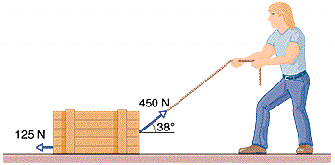](http://www.google.com/url?sa=i&rct=j&q=&esrc=s&source=images&cd=&ved=0ahUKEwj_ufa0x_rPAhWB6SYKHdahAmMQjRwIBw&url=http://www.chegg.com/homework-help/questions-and-answers/1-worker-drags-crate-across-factory-floor-pulling-arope-tied-crate-worker-exerts-force-450-q362052&psig=AFQjCNED4BQmcYisqEGRovkDZNZ3Dm5G9g&ust=1477643037011222)

1. Two masses, *m1,* and *m2* connected by a cord over a frictionless pulley is called Atwood’s Machine. Show that the acceleration of the Atwood’s machine appratus and the tension in the cord are given by:



1. A 14.5 kg box rests on a 25.0 frictionless incline and is connected to a wall by a rope that is parallel to the incline. Determine the tension in the rope and the normal force of the ramp on the box.

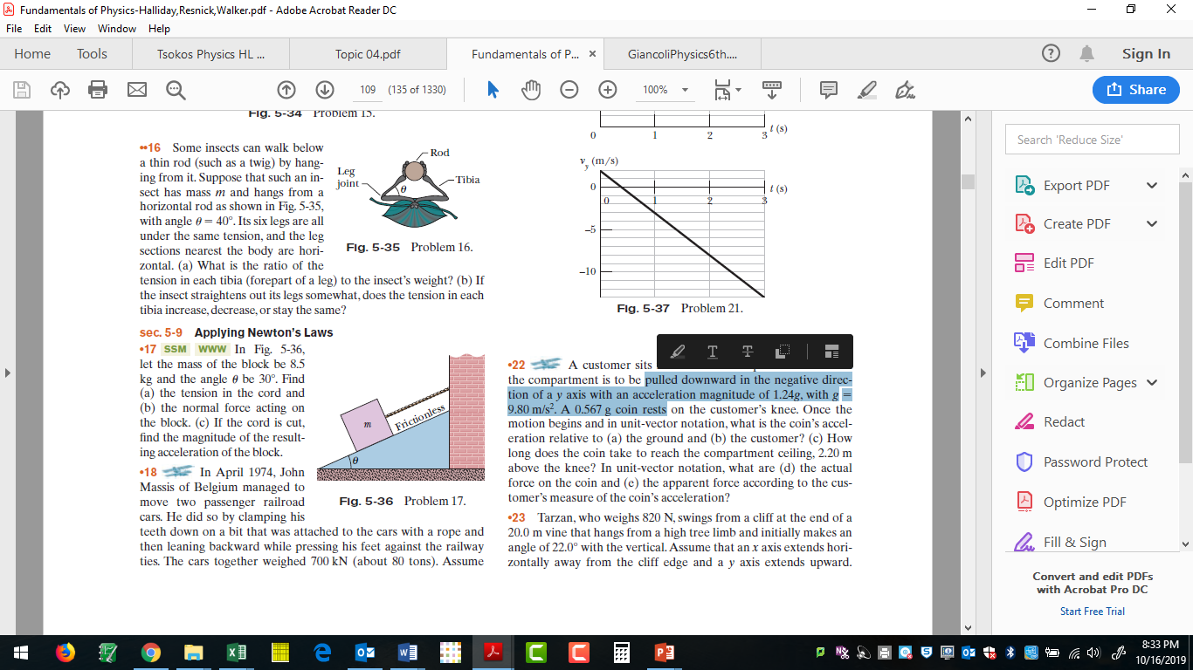

1. Two blocks are in contact on a frictionless table. A 3.20 N horizontal force is applied to the left-hand larger block. a) If the mass of the larger block is 2.35 kg, and the mass of the smaller block is 1.25 kg, find the force between the two blocks. b) What is the acceleration of the blocks? c) Repeat a) and b) if the force instead is applied to the smaller right-hand block. (Hint: you may or may not get the same answers.)
2. A 100 kg crate is pushed at constant speed up a frictionless 30.0° ramp as shown. a) What horizontal force is required? b) what normal force is exerted by the ramp on the crate? c) What would be the tension in a rope if it was attached to the end of the crate and used to pull the crate up the incline with the rope parallel to the incline? d) what is the new normal force?

[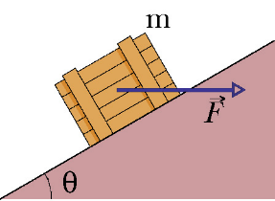](https://www.google.com/url?sa=i&rct=j&q=&esrc=s&source=images&cd=&cad=rja&uact=8&ved=0ahUKEwjkqKjQyPrPAhXF2SYKHXdmCFwQjRwIBw&url=https://www.chegg.com/homework-help/questions-and-answers/physics-archive-2016-june-09&bvm=bv.136811127,d.eWE&psig=AFQjCNEV36zhDhEzx51AHmasZ8H7AugcKg&ust=1477643341175752)